Force Sensing Resistor Lab Report

Force Sensing Resistor Lab

by

Andrew Struthers

This lab was to demonstrate the proper use of an NI Data Acquisition Device (DAQ) and a Force Sensing Resistor (FSR) to light an LED when a given force is met.

Introduction

The main point of this experiment is to gather force data from a force sensing resistor (FSR) and a programmable voltage source using an NI Data Acquisition Device (DAQ). The lab involves using a NI-9205 module for the DAQ, a different NI DAQ module to control a digital output, and a force sensing resistor with a parallel voltage divider with a RM value rating of 10k ohms. The software used is NI software version 18.0 for the coding and other software. This experiment involves measuring force using a force sensing resistor. The process will include acquiring voltage readings from the FSR, using the spec sheet to relate voltage to force, lighting an LED when a threshold is met, then displaying data to a graph.

Software

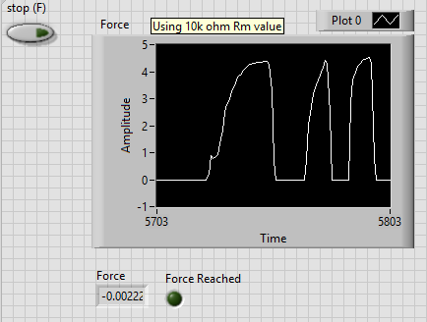To start this lab, a VI with a front panel shown in Figure 1 was to be constructed. The front panel is relatively straightforward. There is a waveform chart for graphing voltage as a function of time. There is also a double numeric display at the bottom of the chart to display the current voltage reading. Next to the numeric display is a LED that will light up when a threshold of force is reached. There is also a stop button that will end the entire code, shutting off communication with the NI DAQ modules.

Figure - Front Panel of VI with Data on Chart

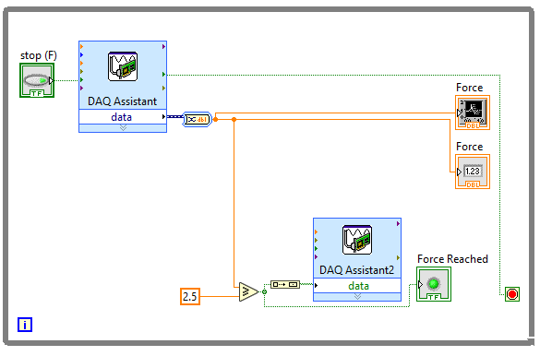The second half of the software of this lab involved wiring the block diagram of the VI to do what was needed. The code for this VI is shown in Figure 2. First, the DAQ assistant needed to be set up to look for voltages in the range 0V – 5V, at a rate of 1k Hz and a sample collection of 100 data points. This way, the response speed of the VI will be quite quick. The output from the DAQ assistant is then routed through a convert from dynamic data converter, so that the data from the DAQ will be one double value. This value is then wired to the waveform chart and the numeric display from the front panel. Additionally, the double number is compared to see if the value is greater than 2.5 volts. If so, the LED from the front panel lights up. Also, the DAQ Asistant2 Express VI is responsible for providing a digital output to port 1 of its module, when the condition is true. This will eventually light up the appropriate LED in the circuit.

Figure - Block Diagram of VI

Hardware

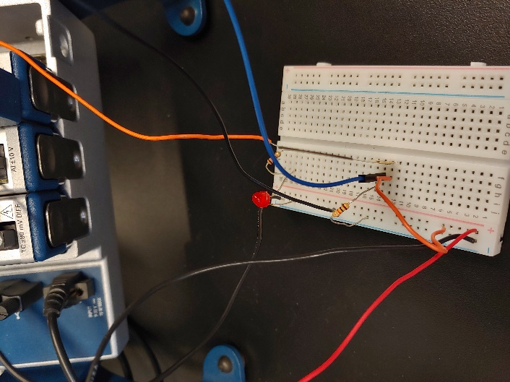 With this code complete, the software side of the lab is done, and the hardware section can be finished. The hardware involved in this lab was a 10K ohm resistor, a force sensing resistor, a red LED, and a PWS4305 programmable power supply. The wiring is shown in Figure 3. A picture of the whole wiring setup is available in figure 4.

Results

The module started collecting data from the force sensing resistor, and the resulting voltages were displayed on the chart and the numeric display. The force sensing resistor was really fast to respond when there was any sort of pressure applied. The chart in Figure 1 is the chart from the active test of this experiment. When the force exerted on the force sensing resistor reached 300n, the red light lit up and the project worked exactly as it should have.

Figure - Close Up Wiring Picture

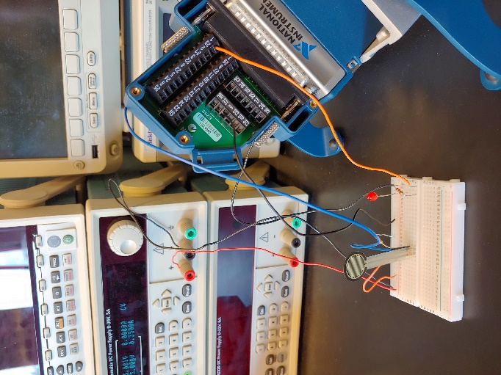Troubleshooting

The wiring took a bit to figure out, and there were some unexpected results initially. The VI was not displaying the correct force, it was either displaying 5 volts or -5 volts, no in between. After troubleshooting, two things were noticeably wrong. One, the wiring of the force sensing resistor wasn’t exactly correct. The output and the resistor were wired opposite to how they should be. In addition, the output module was never actually grounded, so once the force sensing resistor worked properly, the light was not displaying. After a little bit of puzzling, however, everything worked correctly.

Figure - All Project Hardware

References

The references were as follows:

* Force Sensing Resistor Lab Description - https://canvas.cwu.edu/courses/56610/files/5540180/download?wrap=1